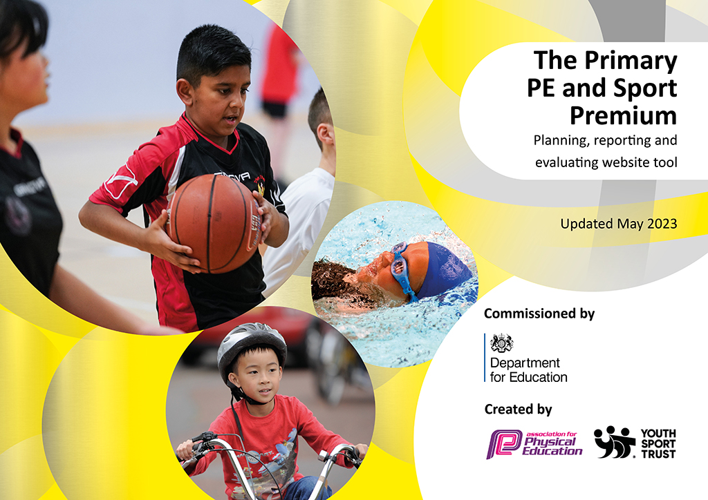
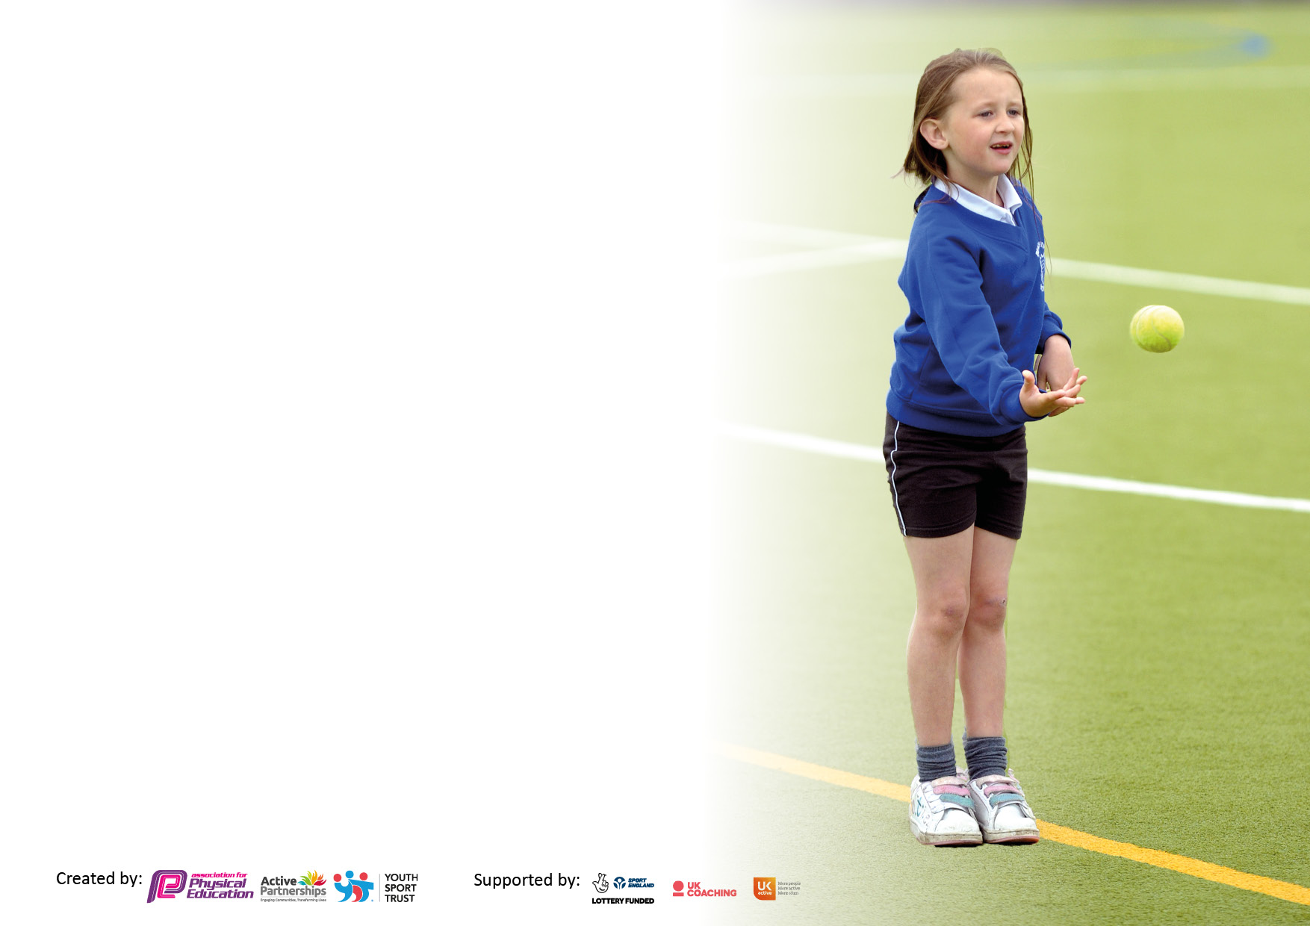

It is important that your grant is used effectively and based on school need. The Education Inspection Framework makes clear there will be a focus on ‘whether leaders and those responsible for governors all understand their respective roles and perform these in a way that enhances the effectiveness of the school’.

Under the Quality of Education Ofsted inspectors consider:
Intent - Curriculum design, coverage and appropriateness
Implementation - Curriculum delivery, Teaching (pedagogy) and Assessment
Impact - Attainment and progress

To assist schools with common transferable language this template has been developed to utilise the same three headings which should make your plans easily transferable between working documents.

Schools must use the funding to make additional and sustainable improvements to the quality of Physical Education, School Sport and Physical Activity (PESSPA) they offer. This means that you should use the Primary PE and sport premium to:

- Develop or add to the PESSPA activities that your school already offer
- Build capacity and capability within the school to ensure that improvements made now will benefit pupils joining the school in future years
- The Primary PE and sport premium should not be used to fund capital spend projects; the school’s budget should fund these.

Please visit gov.uk for the revised DfE guidance including the5keyindicatorsacrosswhichschoolsshoulddemonstrate an improvement. This document will helpyoutoreviewyourprovisionandtoreportyourspend.DfEencouragesschools to use this template as an effective way of meeting the reporting requirements of the Primary PE and Sport Premium.

We recommend you start by reflecting on the impact of current provision and reviewing the previous spend.

Schools are required to publish details of how they spend this funding, including any under-spend from 2021/2022, as well as on the impact it has on pupils’ PE and sport participation and attainment. The funding should be spent by 31st July but the DfE has stated that there will be no clawback of any unspent money so this can be carried forward into 2023/24.

We recommend regularly updating the table and publishing it on your website throughout the year. This evidences your ongoing self-evaluation of how you are using the funding to secure maximum, sustainable impact. Final copy must be posted on your website by the end of the academic year and no later than the 31st July 2023. To see an example of how to complete the table please click HERE.

Details with regard to funding
Please complete the table below.

Total amount carried over from 2021/22 | £0.00
Total amount allocated for 2021/22 | £19,921.60
How much (if any) do you intend to carry over from this total fund into 2022/23? | £0.00
Total amount allocated for 2022/23 | £17,760.00
Total amount of funding for 2022/23. Ideally should be spent and reported on by 31st July 2023. | £17,760.00
Swimming Data
Please report on your Swimming Data below.

Meeting national curriculum requirements for swimming and water safety.

N.B. Complete this section to your best ability. For example you might have practised safe self-rescue techniques on dry land which you can then transfer to the pool when school swimming restarts.
Due to exceptional circumstances priority should be given to ensuring that pupils can perform safe self rescue even if they do not fully meet the first two requirements of the NC programme of study
What percentage of your current Year 6 cohort swim competently, confidently and proficiently over a distance of at least 25 metres?  N.B. Even though your pupils may swim in another year please report on their attainment on leaving primary school at the end of the summer term 2023.  Please see note above | 68%
What percentage of your current Year 6 cohort use a range of strokes effectively [for example, front crawl, backstroke and breaststroke]?  Please see note above | 68%
What percentage of your current Year 6 cohort perform safe self-rescue in different water-based situations? | 68%
Schools can choose to use the Primary PE and sport premium to provide additional provision for swimming but this must be for activity over and above the national curriculum requirements. Have you used it in this way? | No

Action Plan and Budget Tracking
Capture your intended annual spend against the 5 key indicators. Clarify the success criteria and evidence of impact that you intend to measure to evaluate for pupils today and for the future.

Academic Year: 2022/23 | Total fund allocated: £17,760 | Date Updated: 10th May 2023
Key indicator 1: The engagement of all pupils in regular physical activity – Chief Medical Officers guidelines recommend that primary school pupils undertake at least 30 minutes of physical activity a day in school |  |  |  | Percentage of total allocation:
 |  |  |  | 31%
Intent | Implementation |  | Impact
Your school focus should be clear what you want the pupils to know and be able to do and about  what they need to learn and to  consolidate through practice: | Make sure your actions to achieve are linked to your intentions: | Funding allocated: | Evidence of impact: what do pupils now know and what can they now do? What has changed?: | Sustainability and suggested next steps:
Lunchtime activities led by lunchtime sports leader, Playtime Crew and Lunchtime Crew. | Sports TA employed specifically for leading activities. | £4,554 | Number of children from each year group participating.  Verbal feedback.  Overview of activities.  Greater number achieving expected standard in core PE lessons.  School assessment tracker. | Commitment to continue providing lunchtime activities.
Lunchtime activities feature a wide range of play equipment for children to use physically and creatively. | Use of Scrapstore to provide materials for children to use during their physical play. | £1,005 | Pupil feedback.  Staff observations. | Continued use of Scrapstore stock, including refreshing available materials on a quarterly basis.
Replace play equipment (due to wear and tear) for children to use physically and creatively at lunchtimes. | Replacement of equipment available. | £87 | Pupil feedback.  Staff observations. | Commitment to continue providing lunchtime activities.
Key indicator 2: The profile of PESSPA being raised across the school as a tool for whole school improvement |  |  |  | Percentage of total allocation:
 |  |  |  | 2%
Intent | Implementation |  | Impact
Your school focus should be clear what you want the pupils to know and be able to do and about  what they need to learn and to  consolidate through practice: | Make sure your actions to achieve are linked to your intentions: | Funding allocated: | Evidence of impact: what do pupils now know and what can they now do? What has changed?: | Sustainability and suggested next steps:
Ensure that school grounds facilitate effective PE lessons, with adequate space and surfaces available to field sports. | Ground maintenance (5% cost of overall) | £284 | Grounds have been available for use by sports clubs and at lunchtimes for sports activities, such as football. | Continue to ensure that school grounds are in an excellent state for team sports.

Key indicator 3: Increased confidence, knowledge and skills of all staff in teaching PE and sport |  |  |  | Percentage of total allocation:
 |  |  |  | 35%
Intent | Implementation |  | Impact
Your school focus should be clear | Make sure your actions to | Funding | Evidence of impact: what do | Sustainability and suggested
what you want the pupils to know | achieve are linked to your | allocated: | pupils now know and what | next steps:
and be able to do and about | intentions: |  | can they now do? What has
what they need to learn and to |  |  | changed?:
consolidate through practice:
Well-structured PE lessons which ensure that PE benefits from a unique, child centered approach that includes, challenges and supports all children. | Subscription to Jasmine (real PE) | £740 | Staff use Jasmine in weekly indoor PE lessons.  Observations.  Pupil voice. | Continued subscription to Jasmine, to ensure that children can continue to develop their PE skills and teacher’s subject knowledge and skills at using the scheme continue to be utilized.
Increased staff confidence in all areas of PE calendar provided by CSET partnership. | All staff and students are made aware of CPD opportunities and encourage to attend. | £3,321 | Increased confidence and subject knowledge in PE across all staff involved in PE. | Continue to monitor and evaluate the programme with staff and pupils.  Find out what other CPD opportunities staff members would like and implement next year.
Increased staff knowledge and skills for PE teaching, along with shared good practice across a hub of local schools, including leadership of a PE team.  Ensuring that PE and school sport is visible in the schools (assemblies, notice boards, school website, local press, pupil reward and recognition of pupils). | Staff meetings to enable knowledge and skills development of staff and consistency of approach.  Leadership time for PE lead to plan and develop this area of the curriculum | £1,569  (staff training, 2 hours per quarter)  £570  (2 hours per month) | Staff knowledge and skills increased, as evident in pupil voice, teacher voice and observations | Continued participation with local schools to share good practice.  Continued opportunities for staff training in PE to increase confidence, knowledge and skills.
Key indicator 4: Broader experience of a range of sports and activities offered to all pupils |  |  |  | Percentage of total allocation:
 |  |  |  | 30 %
Intent | Implementation |  | Impact
Your school focus should be clear | Make sure your actions to | Funding | Evidence of impact: what do | Sustainability and suggested
what you want the pupils to know | achieve are linked to your | allocated: | pupils now know and what | next steps:
and be able to do and about | intentions: |  | can they now do? What has
what they need to learn and to |  |  | changed?:
consolidate through practice:
Provision of grounds and equipment to Firsts Sports, to maximize the availability of a range of sports to children and reduce the cost, increasing accessibility. | First Sports PE lessons for the whole school.  First Sports afterschool football club for PP | £5,244  £156 | Attendance and engagement of children.  Pupil voice.  Parent voice. | Continuation of funded places in afterschool sports clubs for Pupil Premium children, according to individual circumstances.

Key indicator 5: Increased participation in competitive sport |  |  |  | Percentage of total allocation:
 |  |  |  | 2%
Intent | Implementation |  | Impact
Your school focus should be clear | Make sure your actions to | Funding | Evidence of impact: what do | Sustainability and suggested
what you want the pupils to know | achieve are linked to your | allocated: | pupils now know and what | next steps:
and be able to do and about | intentions: |  | can they now do? What has
what they need to learn and to |  |  | changed?:
consolidate through practice:
Increased sense of identity at sporting competitions and increased engagement in PE lessons, via staff who are wearing specialist and easily-identifiable sports kit featuring the updated school logo. | PE kit to be issued to all new staff | £0 | All current staff have PE kit | Ensure staff have PE kit when new to Pucklechurch.  PE kit to be collected in when staff resign.
Opportunities for children to take part in inter-school competitions, leading to increased enjoyment and development of sports. | Coaches to MaD Olympiad.  Hire, trophies and medals | £150  £80 | Pucklechurch take part in MaD Olympiad. | Opportunities for competitive sport.

Signed off by
Head Teacher: | 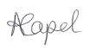
Date: | 13/7/2023
Subject Leader:
Date: | 17/7/2023
Governor: | 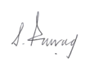
Date: | 13/7/2023

